MODULE-3
Understanding Harmony in the Family and Society- Harmony in Human- Human Relationship

Understanding values in human-human relationship:
The feeling or sense of emotional bonding with others is known as relationship. Relationships are reality of our life. Relationship extends from oneself to the entire existence.

Family is a natural laboratory to understand human relationships:
The family is the basic unit of human interaction. It anchors the roots of relationships in us. It gives us both roots to hold and wings to fly. It is not surprising that children who grow up in happy families are more successful and well-adjusted in life.
Family relations can give us strength to face the world. How wonderful it feels to return to a happy home after a hard day at work? Our family can be our sounding board to bounce off creative ideas, our greatest supporter during adversity and the source of unconditional love. Now imagine a situation where there are very unpleasant relations at home…bitter fights, jealousies and the blame game being played out! A person would actually hate going home of such an oppressive atmosphere.
Family disputes can cause depression, anxiety, sleeplessness, loss of appetite, sadness, confusion and anger. No one wants to live like that! So we need to follow simple rules for turning family disputes into family fun.

Nine Universal values in relationships:
There are certain basic and important values in maintaining relationship. These values, we all know, are the backbone of health and happy family relations. The feelings, emotions, sentiments and respect all are of real importance. These values lead to elimination of friction and establishment of total harmony in relationship on long term basis. Values that are important in any relationship are

1. Trust- Vishwas (Foundational Value) : Trust or vishwas is the foundational value in relationship. "To be assured that each human being inherently wants oneself and the other to be happy and prosperous." If we have trust in the other, we are able to see the other as a relative and not as an adversary.

2. Respect - Samman:Respect means individuality. The sense of individuality is prime object. This is the first basic step towards respect (samman). Once we realized that we are individual then only we can see ourself different from others. In other words, respect means right evaluation, to be evaluated as I am.

3. Affection - Sneha: Affection is the feeling of being related to the other. Affection comes when I recognize that we both want to make each other happy and both of us are similar.

4. Care - Mamata: The feeling of care is the feeling to nurture and protect the body of our relative. Or in other words a state of mind in which one is troubled; worry, anxiety, or concern is called care.

5. Guidance - Vatsalya: The feeling of ensuring right understanding and feelings in the other (my relative) is called guidance. We understand the need of self ('I') for right understanding and feelings. We also understand that the other is similar to me in his/her faculty of natural acceptance, desire of wanting continuous happiness and the program of living in harmony at all the four levels.

6. Reverence - Shraddha: The feeling of acceptance of excellence in the other is called reverence. When we see that the other has achieved this excellence- which means to understand and to live in harmony at all the levels of living ensuring continuity of happiness, we have a feeling of reverence for him/her
.
7. Glory - Gaurav: Each one of us wants to live with continuous happiness and prosperity. Each one of us has the similar faculty of natural acceptance, has the same goal and program and we have the same potential to realize this. Glory is the feeling for someone who has made efforts for excellence.

8. Gratitude - Kritagyata: Gratitude is the feeling of acceptance for those who have made efforts for my excellence. Gratitude is an emotion that occurs after people receive help, depending on how they interpret the situation.

9. Love- Prema (Complete Value) : Love is the emotion of strong affection and personal attachment. In other words, love is a feeling of warm personal attachment or deep affection, as for a parent, child, or friend. This feeling or value is also called the complete value since this is the feeling of relatedness to all human beings. It starts with identifying that one is related to the other human being (the feeling of affection) and it slowly expands to the feeling of being related to all human beings.

There are the four aspects to understand about relationship
1. Relationship is – between oneself (I₁) and another self (I₂): In a family, we do not create relationships. Instead we are embedded into relationships that are already there and all that we need to do is to recognize them and understand them.
2. There are feelings in relationship – in one self (I₁) for the other self (I₂): In any relationship, it is the person’s Self (I₁) that is related to the other person’s Self (I₂). The body is only a means to express our relationship. For example, in a mother and a child, it is the Self of the mother and the Self of the child who feel connected. Their bodies are incapable of understanding or having feelings.
3. These feelings can be recognized: The feelings in a relationship between “I” and “I” such as Trust, Respect, Affection, Care, Guidance, Reverence, Glory, Gratitude &Love etc., can be identified with clarity and so they are definite. These feelings are the values which characterize any relationship
4. Their fulfilment, evaluation leads to mutual happiness: Once we recognize the values essential for any relationship, we start working and behaving according to these feelings.
We begin evaluating ours’ and others’ feelings in the relationship. Thus living with these values leads to mutual fulfilment and happiness in all our relationships.

Meaning of Justice (Nyaya) and program for its fulfilment to ensure mutual happiness:

- We want harmony at all levels of livings.
  - Harmony in the family is the building block for harmony in the society.
  - Harmony in the society makes an undivided society, which is the desire of each one of us.
- Justice starts from family and slowly expands to the world family. The child gets the understanding of justice in the family. With this understanding, he goes out in the society and interacts with people.
- Justice is the recognition of values in relationship, their fulfilment, right evaluation and ensuring mutual happiness (Ubhay- Tripti).
- Thus there are four elements of justice: recognition of values, fulfilment, evaluation and mutual happiness ensured. When all the four are ensured, justice is ensured. Mutual fulfilment is the hallmark of justice and justice is essential in all relationships.

If the understanding of justice is ensured in the family, there will be justice in all the interactions we have in the world at large. If we do not understand the values in relationships, we are governed by our petty prejudices and conditionings. We may treat people as high or low based on their body (particular caste, or sex or race or tribe), on the basis of wealth one possesses or the belief systems that one follows.
All this is source of injustice and leads to fragmented society while our natural acceptance is for an undivided society and universal human order. Having explored the harmony in the human beings, we are able to explore the harmony in the family. This enables us to understand the harmony at the level of society and nature/existence. And this is the way, the harmony in our living grows. We slowly get the competence to live in harmony with all human beings.

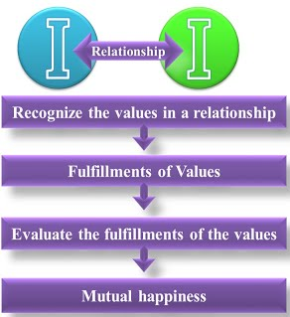

Understanding the meaning of Trust: Difference between intention and competence

Trust or vishwas is the foundational value in relationship. “To be assured that each human being inherently wants oneself and the other to be happy and prosperous” is known as trust. Having faith in others and believing them. Trust is the expectation of people that they can rely on our word. It is built through integrity and consistency in relationships.
To keep the trust on ourself and others, we have to pay attention on the intensions and to understand if we or the other person is not able to do benefit, it is because we are lacking competence. Trust is the result of right understanding of the intention of all the human beings around us. This trust helps to improve our competence in others and in ourselves.

Intention Vs Competence
Both intention and competence are the aspects of trust. Intention is what one aspires for (our natural acceptance) and competence is the ability to fulfil the aspiration. In intention every human being wants to do what is right, only the competence may be lacking which needs to be developed through proper understanding and practice. But what we are doing today is that when we are judging ourself - we are judging on the basis of our intention, whereas, when we are judging the other we are judging him on the basis of his competence.
We trust our own intention while we are not ready to trust the others intention. It is the same for other as well. We find that while we look at our intention, we are sure of it, we are not sure of the other’s intention. We are actually seeing their competence, and making a conclusion on their intention. Hence, mistrust is born and we deny the relationship. We seldom look at our competence and other’s intention.
To be assured that the other human being wants to make me happy & prosperous. Verify the following

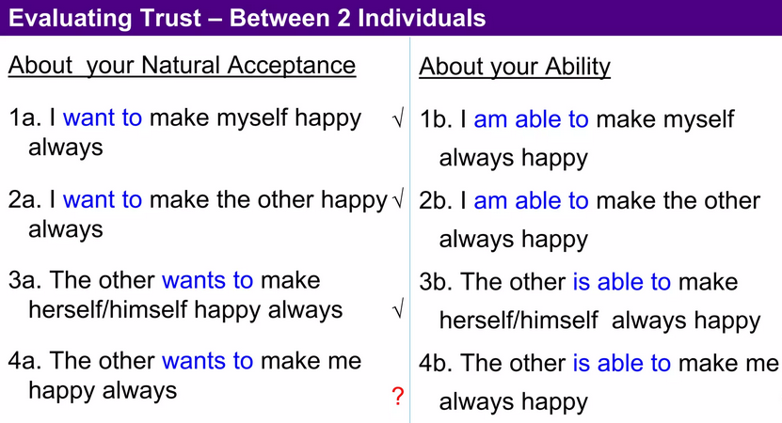

The first four questions are related to our natural acceptance i.e. intention and the next four to our competence. “To be assured that the intention of the other is always correct is trust” We generally evaluate ourselves on the basis of our intention and other on the basis of their competence. If we have trust on intention, we have a feeling of being related to the other & we start helping the other to improve his competence, if he does not have.
Intention and competence are distinct concepts that play important roles in understanding human behavior and performance.

Difference between Intention and Competence

Intention | Competence
- Definition Intention refers to the mental state or plan of an individual regarding what they aim to achieve or how they plan to act in a certain situation. It’s about the goals, desires, or motivations behind actions. Intention is about the purpose and motivation behind actions. It reflects what someone aims to do. | - Definition: Competence refers to the actual ability or skill level an individual possesses to perform a specific task or job effectively. It’s about the how of actions, including knowledge, skills, and experience. Competence is about the ability and proficiency in performing actions. It reflects how well someone can achieve their goals.
- Role in Trust: Positive intentions contribute to the emotional dimension of trust. When individuals believe that others have good intentions, it fosters a sense of security and emotional connection. | - Role in Trust: Competence is part of the cognitive dimension of trust has rational belief that individuals have the capability and reliability to meet their commitments and perform effectively.
- Focus: Intention is focused on the motive or purpose behind actions. It’s more about the why and what of actions. | - Focus: Competence is focused on the ability to perform tasks effectively. It’s more about the how well and how one performs a task.
- Example: If someone intends to start exercising regularly, their intention is the goal of improving fitness. | - Example: Being competent in a skill means having the necessary proficiency to carry out that task successfully.
Examples:

- Student:
- Intention: A student might have the intention to study hard and perform well in exams. This intention reflects their desire and commitment to achieve a good outcome.
- Competence: A student who can solve complex mathematical problems quickly and accurately is demonstrating competence in math. Their competence is the result of their skill and knowledge.

- Chef:
- Intention: The intention is to provide an enjoyable dining experience and showcase their culinary talent
- Competence: A chef prepares a gourmet meal with advanced culinary skills, ensuring the food is delicious and well-presented.

Understanding the meaning of Respect, Difference b/w respect and differentiation:

Respect (Sammãna): Respect means “Right Evaluation”, to be evaluated as I am. The sense of individuality is prime object towards respect. Once we realized that we are as an individual then only we can see our self different from others.
Respect = right evaluation
When we evaluate the human being on the basis of Self, we are able to see that:
i. Our purpose is the same – As I have a natural acceptance to live with continuous happiness and prosperity, it is same with the other. So, on the basis of our natural acceptance, we have the same purpose.
ii. Our programme is same – As my programme to achieve continuous happiness and prosperity is to understand the harmony and live in harmony at all levels of my being (from human being to the entire existence), it is same with the other. In that sense, our programme to fulfil our purpose is also same.
iii. Our potential is same – As I am endowed with natural acceptance and the activities of desire, thought and expectation are going on continuously in me, it is the same with the other. So, our potential is also same.

Disrespect: Disrespect defined as acting in an insulting way toward someone, or showing the opposite of respect by being rude, impolite, or offensive.

Usually however, we make mistakes in our evaluation in the following three ways.
i. Over Evaluation (adhi-mülyana) – To evaluate more than what it is.
Example: You are sitting at home and there are guests around. Your father says ‘my son is the greatest scholar in India!’ Check for yourself: do you feel comfortable, or do you feel uncomfortable?
ii. Under Evaluation (ava-mülyana) – To evaluate less than what it is.
Example: You are still at home, but this time your father says ‘My son is a good for nothing. He must be the laziest person in all of India!’ You obviously feel uncomfortable, you don’t find this acceptable.
iii. Otherwise Evaluation (a-mülyana) – To evaluate other than what it is.
Example: You are at home, and there are guests around, and your father says, ‘You donkey! Can’t you even understand this much?’ You feel offended. This is evaluating you otherwise, as you are a human being and not something else.

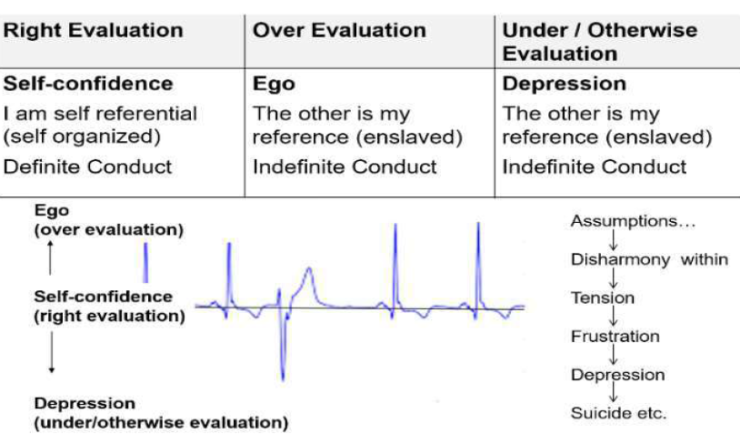

The other is similar to me and the difference could only be at the level of understanding.

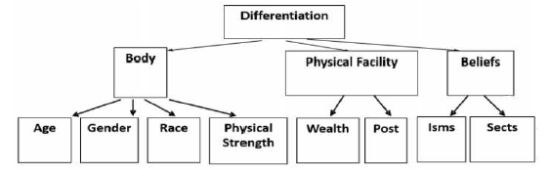

i. On the basis of Body:
I. Age: We have notions such as ‘one must respect elders’. There is no such notion as respect youngsters. Here, we see that we are again evaluating at the level of the body – age is related to the body, and not to ‘I’.
II. Gender: We ignore the fact that being male or female is an attribute of the body, and not an attribute at the level of ‘I’. And differentiate in giving respect on the basis of gender called male and females. In many countries, people even prefer a male child to a female child, and in some other societies, the other way round.
III. Race: If the person is of the same race as oneself, then we treat them differently. For example, we differentiate on the basis of skin colour – white, brown, black etc. or on the basis of whether the person is of Aryan race, Mongolian race etc. or on the basis of caste. Again here, we don’t do the evaluation on the basis of ‘I’, but on the basis of the body
IV. Physical strength: If someone is stronger, we again treat him/her differently. This is again at the level of the body. In fact, we think that we are respecting the other while it is fear; the fear that if we do not treat them like this, we will be harmed.

ii. On the basis of physical facilities
I. Wealth: We differentiate people because some have wealth than others. What we term as a “rich person” gets idolized. We don’t even bother to find out whether such people are feeling prosperous, or if they just have wealth. This way, we are over-evaluating physical facilities first, which are just meant to fulfil the needs of the body, and then on this basis, we are wrongly identifying our relationship.
II. Post: We try to respect on the basis of a person’s position. The post is wrongly evaluated as the mark of a person’s excellence and differentiation sets in. The post is considered important either on the basis that it gives more physical facilities or on the basis that certain positions are assumed to be important. In our education, we are trained directly or indirectly to earn posts for us to fetch respect

iii. On the basis of beliefs
I. ‘Isms’: ‘Ism’ means any belief in terms of a ‘thought-system’ that we have, or that we have adopted. There are also many modern ‘isms’ such as capitalism, socialism, communism, etc. The people following these sets of beliefs are called capitalists, socialists, communists, and so on. The people that have adopted them or are following them have been exposed to them since childhood. Believing theirs to be the right belief. However, all beliefs, as we have seen are at the level of desires, thoughts and expectations (selections) in ‘I’. There is no definiteness at this level, and hence, this becomes a cause for differentiation.
II. Sects: People of one sect only consider those with a similar belief system to be their ‘own’ and worthy of respect. Following a particular tradition, or what we call as religion, becomes the basis of respect and disrespect in relationship.

The Problems Faced Due To Differentiation (Disrespect) in Relationships:

- Differentiation based on gender: Issue of women’s rights, and women protesting and demanding for equality in education, in jobs, and in peoples’ representation. People are insecure and afraid of one another based on their gender.
- Differentiation based on race: there are many movements and protect against racial discrimination and demands for equality, racial attacks, movements against cast discrimination has people living in fear of such racism, racist attacks, casticism and discrimination.
- Differentiation based on age: Protests and movements demanding for equal rights for children on the one hand and for rights for elderly people on the other, generation gap
- Differentiation based on wealth: Class struggle and movements to do away with class differentiation. Many people suffering from a lack of self-esteem and some even committing suicide,
- Differentiation based on post: Protests against high handed government officials. At the level of the individual, leads to depression, etc.
- Differentiation based on ’isms: Fights, turmoil, terrorism and war, people converting from one Ism to another in order to be able to get more respect.
- Differentiation based on sects: Countless religions and sects and each sect has its own movement to ensure that there is no discrimination against people of their belief and demands for special provisions in jobs and in education.

Difference between Respect and Differentiation (Disrespect)

RESPECT | DISRESPECT
- Respect means ‘right evaluation’ | - Disrespect means ‘wrong evaluation’
- In our evaluation, respect follows one way ‘right in evaluation’. | - In our evaluation, disrespect follows three ways – over evaluation, under evaluation, otherwise evaluation.
- If we are rightly flattered or get respect we feel comfortable. | - If we are wrongly flattered or get disrespect we feel uncomfortable.
- Feeling of respect is naturally acceptable to us | - Feeling of disrespect is not acceptable to us
- Respect works as a bridge in relationship. | - Disrespect is cause of many problems in relationship.

Understanding the harmony in the society

Harmony in society refers to a state of cooperation and mutual understanding between individuals and groups, characterized by a lack of conflict and a sense of unity and stability. It involves the balance and coordination of diverse interests, values, and beliefs to create a cohesive and functional community.

Comprehensive human goals: In order to facilitate the fulfilment of the basic aspirations of all human beings in the society, the following human goal needs to be understood in a comprehensive manner:

1. When one does not have the right understanding, one remains disturbed and also acts in a manner so as to create disharmony with other human being as well as with rest of nature.
2. Prosperity in the family means that the family is able to identify its needs and is able to produce/ achieve more than its requirements.
3. Trust in society means every member of society feels related to everyone else and therefore there is trust and fearlessness.
4. Co-existence in nature means there is a relationship and complementarily among all the entities in nature including human beings.

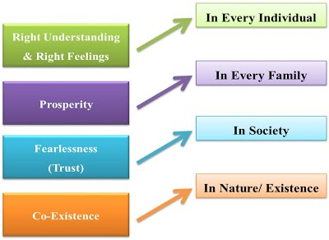

Understanding meaning of Abhaya means fearlessness in society:

It is a permanent state where there is no question of ever experiencing any fear. A person with abhaya is continuously aware if his own reality; for him to become subject to fear would be impossible.
We should not consider this quality of abhaya as just the absence of fear. The fearlessness in the society begins from the individual. We need to ensure right understanding in the individual as the foundation of harmony in the society. With right understanding, the need for physical facilities in the family can be ascertained.
By assessing our needs correctly and by producing more than required the family can be prosperous. Assurance of right understanding in the individuals and prosperity in the families, understanding of human relationships leads to harmony and trust (fearlessness) in the society.
When every individual is able to live harmoniously in relationship, and the needs of all the families are ensured, fearlessness (mutual trust) in society will naturally follow. Thus the state of absence of fear at society level will only be achieved when we have right understanding at individual level and prosperity at the level of family.

Programs to achieve comprehensive human goals (OR)
Five dimensions of human endeavour in society conducive to ‘manaviya vyavastha’

Comprehensive human goals are right understanding, prosperity, fearlessness and co-existence. Programs needed to achieve the comprehensive human goals are:
1. Education – Right Living (Siksha – Sanskar)
2. Health – Self Regulation (Swasthya – Sanyam)
3. Exchange – Storage (Vinimaya – Kosh)
4. Production – Work (Utpadan – Kriya)
5. Justice – Preservation (Nyaya – Suraksha)

1. Education – Right Living: Education refers to understanding harmony at all four levels of living. While right living refers to commitment and preparedness to live in harmony at all four levels of living.
Education – Right living leads to Right understanding: Having the process of education and right living leads to right understanding in the individual.

2. Health – Self Regulation: Sanyama refers to a feeling of responsibility for nurturing, protecting and rightly utilizing the body. When the body is fit to act according to the needs of the self (‘I’), and, there is harmony among the parts of the body, it is referred to as health or svasthya.
Health – Self-regulation leads to Prosperity: Having the program for health and sanyam leads to well-being of the body, and identification of need for physical facilities which along with production ensures feeling of prosperity in the family.

3. Exchange – Storage: Exchange (vinimaya) refers to the exchange of physical facilities between the members of the society, while storage (kosa) refers to the storage of physical facilities that is left after fulfilling the needs of the family.
Exchange – Storage leads to Fearlessness and Prosperity: When we store and exchange for mutual fulfilment and not for exploitation, then it leads to fearlessness (trust) in society.

4. Production – Work: The Body needs material input. Human endeavor needs material input. The efforts we apply on the rest of nature to get material things is called Work. Production is a result of work. On understanding Coexistence, work follows the approach below:
- We produce as much as is needed to fulfill and exceed the material requirements of the Family. Since the need of the Body is limited, production is also definable and becomes limited.
- The method of production follows the inherent laws of cyclicity in Nature – human production thus not only sustains Nature, but can also enrich it.
Production – Work leads to Prosperity and Co-existence: Production and work are for physical facilities, and this leads to a feeling of prosperity in the family. Production is done in harmony with nature, and hence, this also leads to co-existence with nature.

5. Justice – Preservation: Justice (nyaya) refers to harmony in the relationship between human beings, while preservation (suraksha) refers to harmony in the relationship between human being and the rest of nature.
Justice – Preservation leads to Fearlessness and Co-existence: Ensuring justice in relationship, or mutual fulfilment in relationship on the basis of values like Trust, Respect, etc leads to fearlessness in society, while Suraksha of nature – via enrichment, protection and right utilization leads to co-existence in nature.

Visualizing a universal harmonious order in society-

- Universal Human Order (Sarvabhauma Vyavastha) - feeling of being related to every unit including human beings and other entities of nature.

The sarvabhauma vyawastha (Universal Human Order) is the state of realizing the freedom of individual in context of this universe. The respect towards mankind and nature is must to establish the universal order. Having understood the comprehensive human goal, we are able to be in harmony not only with human beings, but also with the rest of nature. We are able to see that we are related to every unit in the nature and ensure mutual fulfillment in that relationship. Working on the five dimensions of human endeavour in the light of right understanding, we are able to work for an orderly living of the human society, whose foundational unit is the family and the final destination is the world family.

- Undivided society (Akhanda samaja) - feeling of being related to every human being. An undivided human centric society is one of the higher human goals. Akhand samaj is the state of the society where all people of different religion and thought process live together and work towards betterment of the society.
Three activities can be performed to send the message of a holistic society:

1. Educating society through workshops, seminars and street plays: this is about organizing workshops, seminars and street plays at various levels in society. The activity may be carried out by N.G.O.'s but must receive the support of government organizations. These activities can be categorized into three types which include Knowing the self, Knowing the existence on basis of self, Knowing the definite human conduct which is contribution of self in existence.

2. Value education in educational institutions: value education should be introduced in current education system at all levels - primary school, secondary school, senior secondary school as well as college level.

3. Helping to apply values to the real world: organizations - both government and non-government should open up counselling centres which can help their employees or general public to apply values to real life situations. It is about realizing the alternatives in life. Various individuals are on the way of self-exploration, finding their natural acceptance towards holistic approach of life and realizing it at all levels starting from self (with knowledge) to family (with meaningful relationships), then to society (education - health - production - business - services). The idea is not to live in isolation or individualism but with expansion of SELF to higher levels in the social system.

2 MARK QUESTIONS

What do you mean by harmony in the family?
Family harmony is the relationship created within the family that shows intimacy and love between all family members, both children and parents, which is marked by a strong religious life, togetherness with family members, communication between family members, appreciation and understanding of family members and family members. Does not exhibit bickering or conflicting behavior. Therefore, every parent is responsible for thinking and trying to always create and maintain a good, effective relationship between parents and children and increase the goodness and harmony of life in the family. Parents are aware that only with good relationships can educational activities be carried out effectively and can support the creation of a harmonious family life

List out nine universal values?
- Trust
- Respect
- Affection
- Care
- Guidance
- Reverence
- Glory
- Gratitude
- Love

What do you mean by Harmony in Society?
Harmony in society refers to a state of cooperation and mutual understanding between individuals and groups, characterized by a lack of conflict and a sense of unity and stability. It involves the balance and coordination of diverse interests, values, and beliefs to create a cohesive and functional community. Harmony in society is an essential component of a stable, secure, and prosperous community. To achieve harmony, it is necessary to address the underlying causes of conflict and division, promote open and honest communication, and foster a culture of tolerance and respect for diversity. By promoting harmony in society, individuals and communities can work together towards a shared sense of purpose and a more fulfilling and meaningful future.

What is Trust?
Trust (Visvasa): The feeling of Trust in relationship is defined as: “To be assured that each human being inherently wants oneself and the other to be happy and prosperous. It is considered as the foundational value in Relationship.
There are two aspects in trust:
I. Intention (wanting to – which is our natural acceptance)
II. Competence (being able to do)
Both intention and competence are the aspects of trust. Intention is what one aspires for (our natural acceptance) and competence is the ability to fulfil the aspiration. In intention every human being wants to do what is right, only the competence may be lacking which needs to be developed through proper understanding and practice. With trust on intention, I feel related to the other, and with that at the base, I make a programme based on our current mutual competence. I make effort to assure the other. Trust is the starting point of relationship, of mutual development. But what we are doing today is that when we are judging ourself we are judging on the basis of our intention, whereas, when we are judging the other we are judging him on the basis of his competence.

Distinguish between Intention and Competence.
Intention | Competence
Definition Intention refers to the mental state or plan of an individual regarding what they aim to achieve or how they plan to act in a certain situation. It’s about the goals, desires, or motivations behind actions. Intention is about the purpose and motivation behind actions. It reflects what someone aims to do. | Definition: Competence refers to the actual ability or skill level an individual possesses to perform a specific task or job effectively. It’s about the how of actions, including knowledge, skills, and experience. Competence is about the ability and proficiency in performing actions. It reflects how well someone can achieve their goals.
Role in Trust: Positive intentions contribute to the emotional dimension of trust. When individuals believe that others have good intentions, it fosters a sense of security and emotional connection. | Role in Trust: Competence is part of the cognitive dimension of trust has rational belief that individuals have the capability and reliability to meet their commitments and perform effectively.
Focus: Intention is focused on the motive or purpose behind actions. It’s more about the why and what of actions. | Focus: Competence is focused on the ability to perform tasks effectively. It’s more about the how well and how one performs a task.
Example: If someone intends to start exercising regularly, their intention is the goal of improving fitness. | Example: Being competent in a skill means having the necessary proficiency to carry out that task successfully.
Examples:

- Student:
Intention: A student might have the intention to study hard and perform well in exams. This intention reflects their desire and commitment to achieve a good outcome.
Competence: A student who can solve complex mathematical problems quickly and accurately is demonstrating competence in math. Their competence is the result of their skill and knowledge.
- Chef:
Intention: The intention is to provide an enjoyable dining experience and showcase their culinary talent
Competence: A chef prepares a gourmet meal with advanced culinary skills, ensuring the food is delicious and well-presented.

What is Respect?
Respect (Sammãna): Respect means “Right Evaluation”, to be evaluated as I am. The sense of individuality is prime object towards respect. Once we realized that we are as an individual then only we can see our self different from others.
Respect = right evaluation
When we evaluate the human being on the basis of Self, we are able to see that:
i. Our purpose is the same – As I have a natural acceptance to live with continuous happiness and prosperity, it is same with the other. So, on the basis of our natural acceptance, we have the same purpose.
ii. Our programme is same – As my programme to achieve continuous happiness and prosperity is to understand the harmony and live in harmony at all levels of my being (from human being to the entire existence), it is same with the other. In that sense, our programme to fulfil our purpose is also same.
iii. Our potential is same – As I am endowed with natural acceptance and the activities of desire, thought and expectation are going on continuously in me, it is the same with the other. So, our potential is also same.

List out sources of Differentiation?


What is Comprehensive Human Goal?

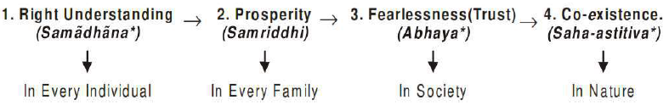

- Right understanding is necessary for the human being, for all human beings. When one does not have the right understanding, one remains disturbed and also acts in a manner so as to create disharmony with other human being as well as with rest of nature.
- Prosperity is needed in every family. Prosperity in the family means that the family is able to identify its needs and is able to produce/achieve more than its requirements.
- Trust in society means every member of society feels related to everyone else and therefore there is trust and fearlessness.
- Co-existence in nature means there is a relationship and complementarily among all the entities in nature including human beings. All the above four are the basic requirements to ensure happiness and prosperity at all levels and achieving all those should be the comprehensive human goal.

